Step 1:

Create a python file with the name app.py

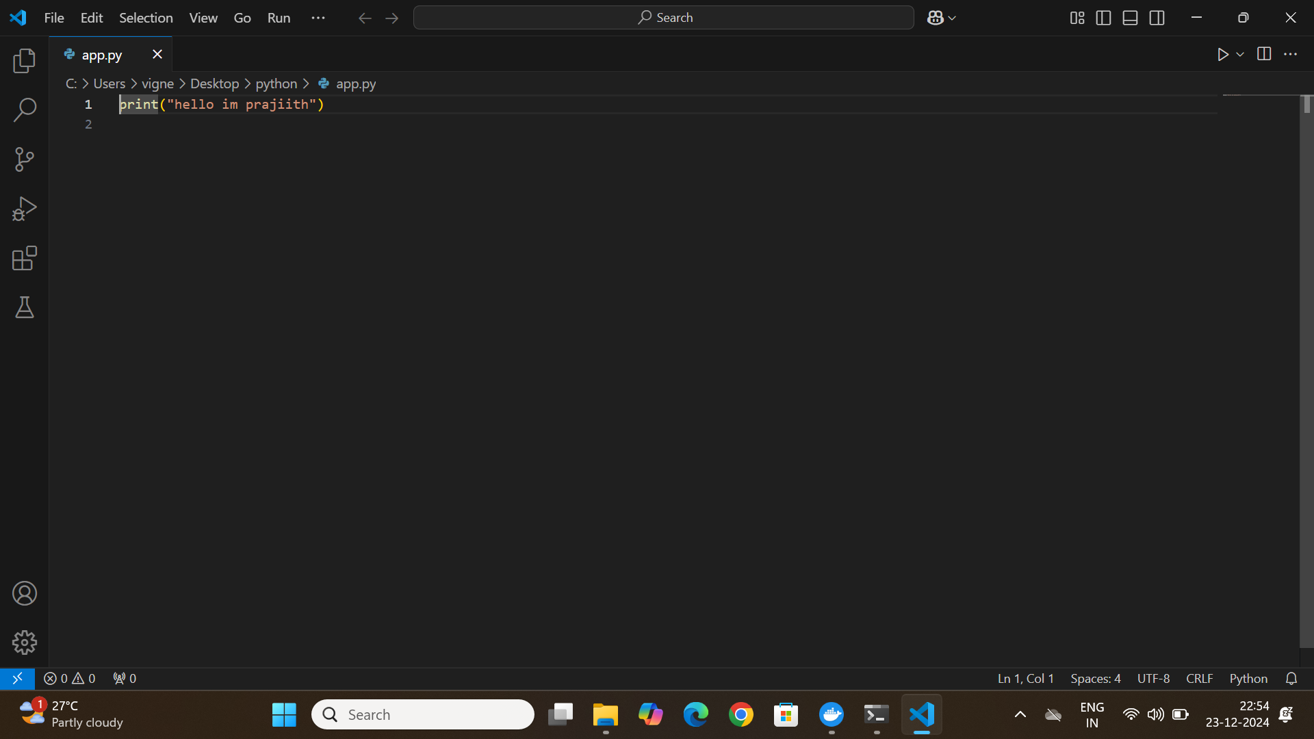

Save it in inside an empty folder

Step 2:

Create a Docker file with File extension. Use double quotes while saving. Save it in the same empty folder

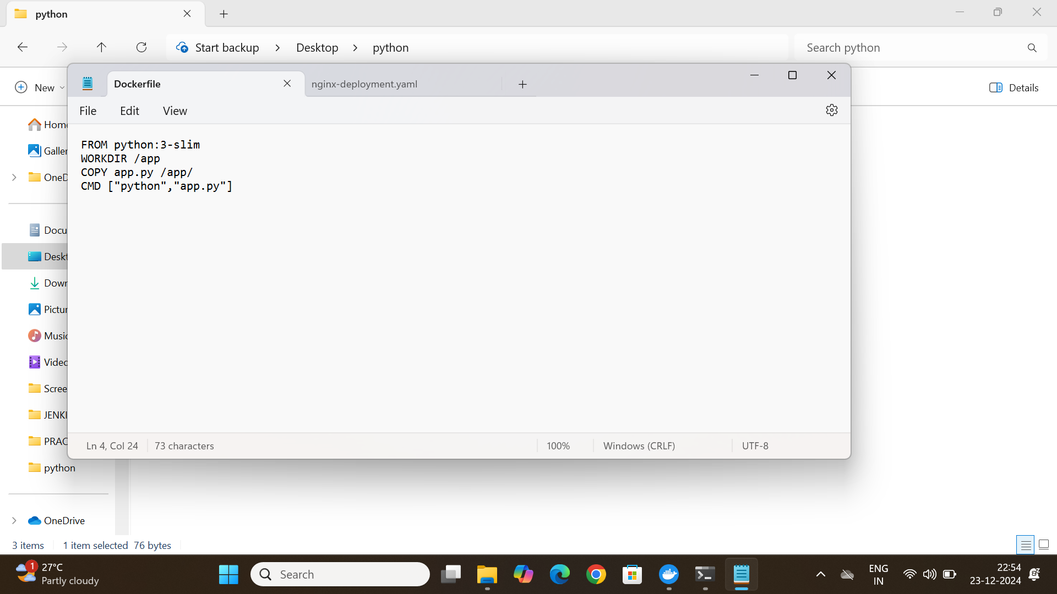

Step 3:

Go to the command prompt in the same folder

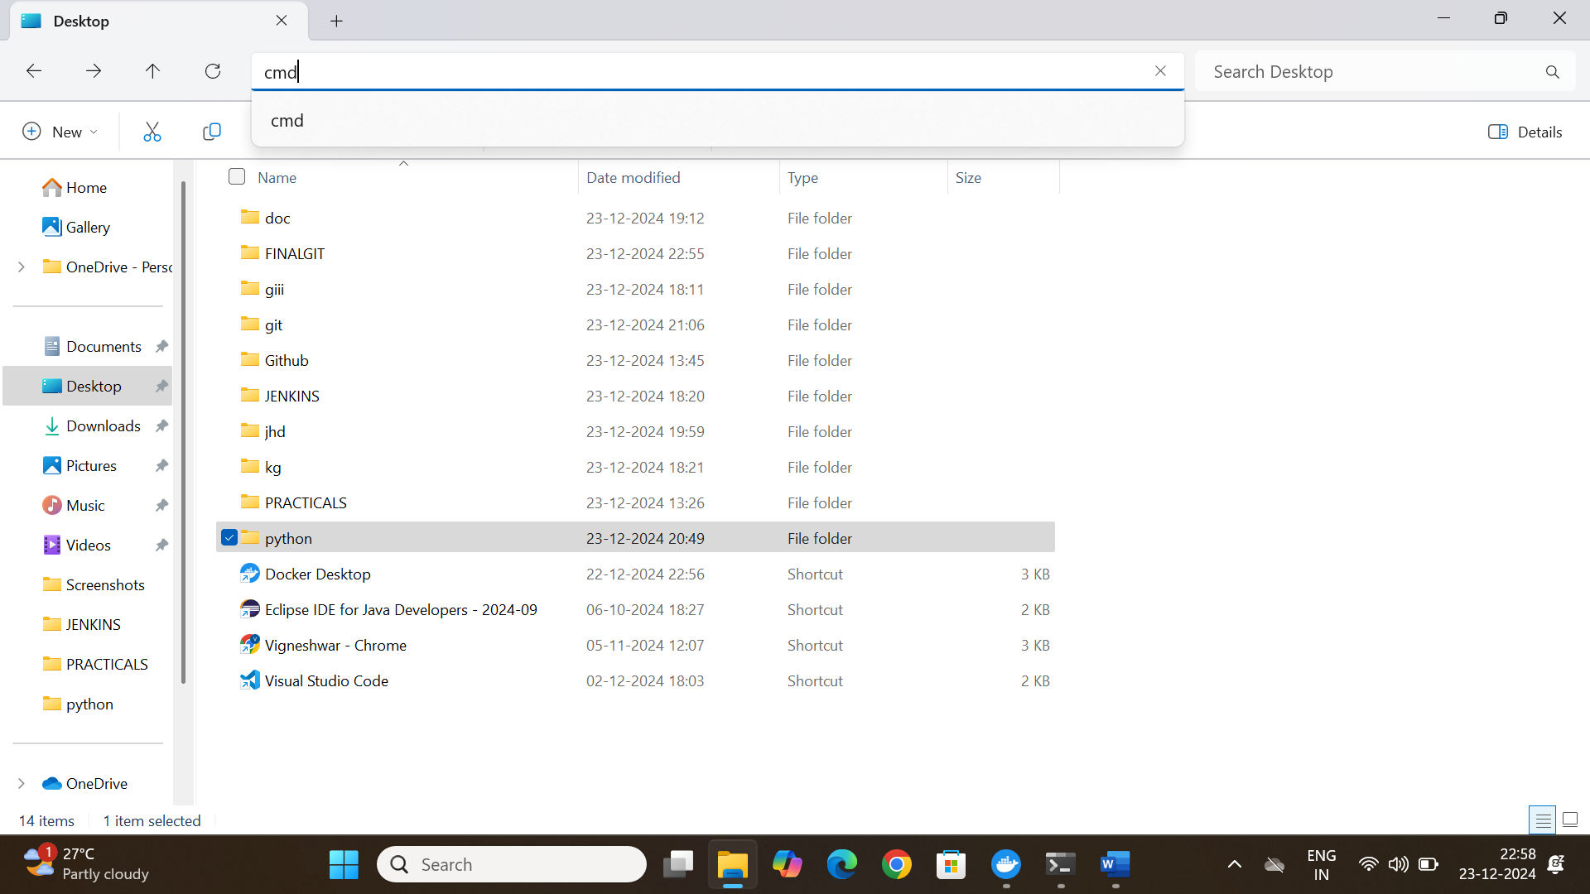

CODE in cmd:

docker build -t python3-prajiith .

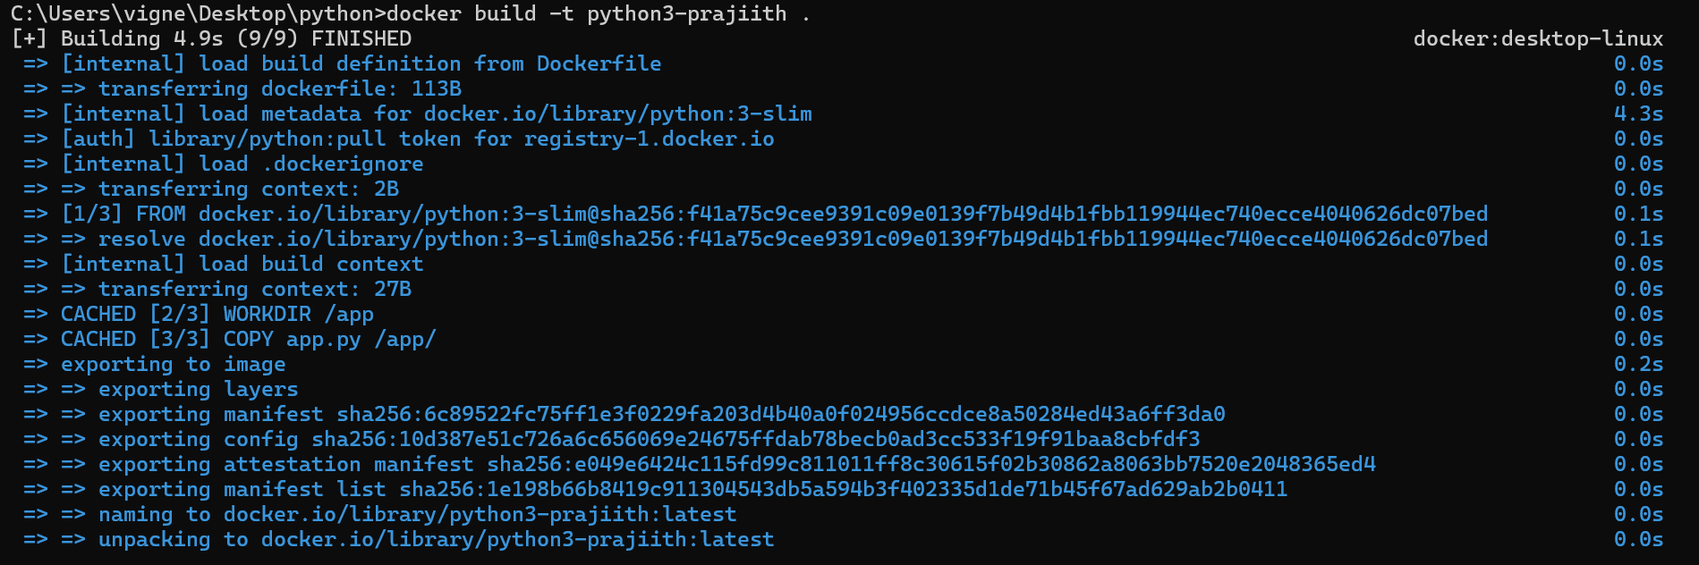

docker run python3-prajiith



Docker login



docker tag python3-prajiith prajiith/python3-prajiith

docker push prajiith/python3-prajiith

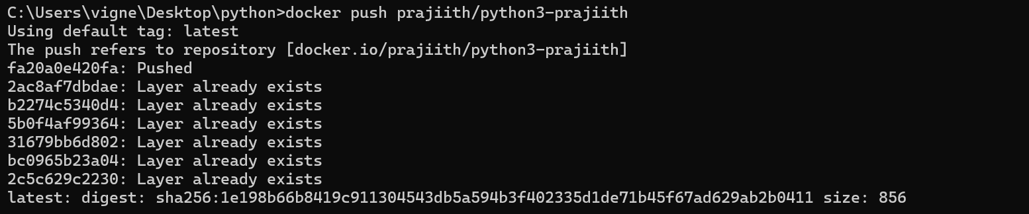

Here python3-prajiith is our container name

In the last two lines we will be using “prajiith” because it is my docker desktop username.

